

Formative feedback

Student name | Kevin Davis | Student number | 516710
Course/Unit | Context and Narrative | Assignment number | 3
Type of tutorial | Written | Formative

Overall Comments
In this assignment you have outlined your intentions and these has been underpinned by analysis of your thinking and critical process in developing the ideas, in selecting the images aand explaining how they link to self-portraiture. The images on the selected theme have an empathy with the tools and objects selected but indicate a more complex relationship in the identification of the self. How can the viewer relate their experiences and feelings to these images? How can the work be interpreted as a self-portrait? In one sense it may be that the work states these tools, to the viewer inform and create the person that is me. Here the photographer is not invisible but although semi-hidden is a strong presence. Alternatively the tools could be interpreted as labels pinned to the identifying of stereotypical roles and traits. You have evidenced analysis of your thinking and critical process in developing the ideas
The coherence of the work in relation to concepts of self-portraiture is clear and you have not being afraid to challenge yourself in this particular situation by adopting a conceptual approach to the work. This has been a good attempt to investigate complex ideas that are starting to be underpinned by critical analysis and research to resolve issues.
There is a good continuity of narrative in this work and this is an area that you should continue to develop through photographing subjects that have a particular interest or curiosity for you.

Feedback on assignment
The research and reading undertaken for this work represents an engagement with series of complex ideas striving to reach a resolution. The images are infused with the self-reference to your own memories and implies a narrative. This narrative can be seen within the context of the life lived, the life imagined and the life desired.
The image at a technical level has challenged you through the necessity of having to direct the taking of the some images in different situation. However this has been resolved and you have produced a technically proficient piece of work.
There are many influences attached to this work but you have still managed to find your individual voice. These are quiet images with no drama and yet at the same time there is an ambiguity that denies a definitive interpretation.
Can the viewer take at face value what these images represent? In your writing you refer to the inner conflict about your work and the possibility of change. This notion of change comes across strongly in your text but not so much in the images and yet this may very well be the key to a truer portrait of you. The images provoke questions for the viewer and offers suggestions of narratives of memory, imagination and autobiography.
I particularly like the images of the different objects that are seen out of context and have started to become abstract in their style. The images of the ballcock is slightly menancing and the plug hole is potentially a landscape. The tool images are straightforward but I would like to have seen each tool situated on a different background. The body parts tell the story and they remind me of Paul Seawright’s police force series.

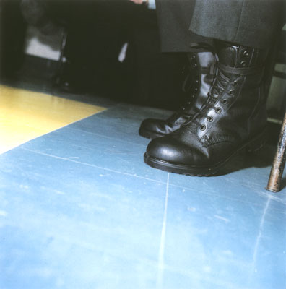
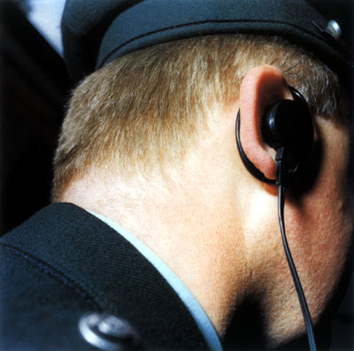

You have included contact sheets for this assignment and there are clearly more images that you could use in this assignment. I was taken with the image of the knees 9430.
Overall this work indicates your evolution over the course module and consolidates a number of your ideas and interests. There are many areas here for future exploration as you continue to grow an individual voice. A good piece of work.

Coursework
You have engaged with all of the prescribed exercises.

Research
The prescribed research has been undertaken and you have made interesting and relevant comments on this work. I like your comments on Francesca Woodman as they take a balanced an objective view of her work. The circumstances of her death appear to halt any critical view of the work that in ways is similar to the juvenilia of many established living photographers. In many ways the cult surrounding her has led to the objectification of a life into a demeaning romanticism.
Good to see that you engaged with primary research by attending the Martin Parr talk.

Learning Log
I was pleased to see that you had looked at the work of other photographers and that you had engaged in background reading and research. You have started to use the log as a means of working out your own ideas and have raised issues surrounding identity and gender stereotypes? Could the project have been developed to consider issues concerning the perceived roles of women? It would have been interesting to see how you might have portrayed this in your work. I would also have liked to see your analysis of the contact sheets and your reasons for the rejection and inclusion of the images.
.
Suggested reading/viewing
http://www.paulseawright.com
https://dodgeburnphoto.com/2018/05/photographer-laura-aguilar/
https://nordenhake.com/artists/john-coplans

Pointers for the next assignment / assessment
Continue explore ideas around personal themes.
Engage with further critical reading as an ongoing part of practice.
Research and develop ideas from learning log..

Strengths | Areas for development
Willing to explore challenging genre, | Develop and consolidate the integration of research and practice.
Engagement with prescribed exercises with good analysis and comments. | Use contact sheets to develop work and consider alternatives
Good writing in learning log underpinning assignment themes/ | Select texts for critical reading appropriate to the assignment

Tutor name | Matthew Winterlich
Date | 13/03/2020
Next assignment due | 24/05/2020

